**A**

**Project Report**

**On**

**Single Image De-Hazing Using Globally Guided Image Filtering**

**ABSTRACT**

Local edge-preserving smoothing techniques such as guided image filtering (GIF) and weighted guided image filtering (WGIF) could not preserve fine structure. In this paper, a new globally guided image filtering (G-GIF) is introduced to overcome the problem. The G-GIF is composed of a global structure transfer filter and a global edge-preserving smoothing filter. The proposed filter is applied to study single image haze removal. Experimental results show that fine structure of the dehazed image is indeed preserved better by the proposed G-GIF and the dehazed images by the proposed G-GIF are sharper than those dehazed images by the existing GIF.

***Index Terms***— Globally guided image filtering, structure transfer, edge-preserving smoothing, single image haze removal.

**Chapter-1**

**INTRODUCTION**

The execution of visual activities such as object detection and recognition depends heavily on the perception of outdoor natural scenes. Unfortunately, images of outdoor scenes are often degraded in bad weather conditions such as haze, fog, smoke, rain and so on. The light is blended with ambient light reflected from other directions into the line of sight by atmospheric particles. The irradiance received by the camera from the scene point is attenuated along the line of sight. As such, the objects captured under the bad weather conditions suffer from low contrast, faint color, and shifted luminance [1]. Haze removal can significantly increase the contrasts of the objects, and correct the color distortion caused by the airlight. Therefore, haze removal is highly demanded in image processing and computer vision applications [2].

Many single image haze removal algorithms were proposed due to their broad applications. Based on an observation that a haze-free image has higher contrast than its haze image, an interesting single image haze removal algorithm was proposed in [3] by maximizing the local contrast of the restored image using markov random field. Although the algorithm in [3] is able to achieve visually compelling results, it tends to produce over-saturated images which might not be physically valid. A haze image is interpreted by Fattal in [4] through an image formation model that accounts for both surface shading and scene transmission. Under an assumption that the transmission Manuscript received June 24, 2016; revised July 31, 2017; accepted August 29, 2017. Date of publication September 8, 2017; date of current version November 3, 2017. The associate editor coordinating the review of this manuscript and approving it for publication was Mr. Pierre-Marc Jodoin. (Corresponding author: Jinghong Zheng.) The authors are with the Institute for Infocomm Research, A*STAR, Singapore 138632 (e-mail: ezgli@i2r.a-star.edu.sg; jzheng@i2r.a-star.edu.sg). Color versions of one or more of the figures in this paper are available online at http://ieeexplore.ieee.org. Digital Object Identifier 10.1109/TIP.2017.2750418 and surface shading are locally uncorrelated, the airlightalbedo ambiguity is resolved. The algorithm in [4] produced impressive results except in presence of heavy haze. Inspired by the widely used dark-object subtraction technique [5], a novel dark channel prior based haze removal algorithm was proposed in [6] and [7]. The dark channel prior is based on an observation that it is very often that some pixels of haze-free outdoor images have very low intensity in at least one color (RGB) channel. The algorithm is physically valid and can handle distant objects even in images with heavy haze. However, noise in bright regions including the sky could be amplified by using the algorithm in [6] and [7] even though a lower bound was introduced for the transmission map in [6] and [7]. Based on observations that the color of the scene fades under the influence of the haze and the brightness increases at the same time producing the high value of the difference, a simple color attenuation prior was proposed in [8], and a linear model was then built up to represent the relationship between the depth and the brightness as well as the saturation using the prior. The linear model was finally adopted to design a single image haze removal algorithm with the help of the guided image filtering (GIF) in [7]. The algorithm in [8] is simple and it also avoids amplification of noise in the sky region. In addition, the haze is removed well if it is light. However, the quality of the dehazed images needs to be improved if the haze is heavy. This is because the coefficients of the linear model and the scattering coefficient of the atmosphere are fixed for the algorithm in [8] while their values should be adaptive to the haze degree of the input image. It is interesting but challenging to properly determine the coefficients of the linear model and the scattering coefficient of the atmosphere for the algorithm in [8]. Inspired by an observation in [9] that single image haze removal can be regarded as a type of spatially varying detail enhancement, a neat framework was proposed in [11] by introducing a local edge-preserving smoothing based method to estimate the transmission map of a haze image. However, local edge-preserving smoothing techniques such as the GIF in [7] and the weighted GIF (WGIF) in [9] could over smooth images [12], especially in areas of fine structure. An example is given in Fig. 1. The GIF in [7] and the WGIF in [9] are adopted to study single image haze removal. As shown in the zoom-in regions, the hair of the human subject is over smoothed by both the GIF and the WGIF. Therefore, both the GIF and the WGIF could not preserve the fine structure even though they are very simple.

In this paper, a fast globally guided image filter (G-GIF) is introduced to address the problem. The proposed G-GIF is inspired by the GIF in [7], the WGIF in [9], and the gradient domain image processing algorithms in [10], [13], and [14]. Two major objectives of the GIF and WGIF are: 1) to transfer the structure of the guidance image to the input image; and 2) to smooth the transferred image so as to produce the output image. Both the objectives are achieved simultaneously in the GIF and WGIF. They are achieved separately in the proposed G-GIF. The proposed filter is composed of a global structure transfer filter and a global edge-preserving smoothing filter. Inputs of the structure transfer filter are an image to be filtered and a guidance vector field. The structure is defined by the guidance vector field and it is transferred to the image to be filtered by the structure transfer filter. Unlike the GIF in [7] and the WGIF in [9], the structure transfer filter is formulated as a quadratic optimization problem. Unlike the gradient domain image processing algorithms in [13] and [14], the structure filter is formulated in the hybrid gradient and image domain. As such, the proposed hybrid optimization problem can be easily solved by using the separating approach in [15] even though it is a global optimization problem while the separating approach is not applicable to the gradient domain image processing algorithms in [13] and [14]. The speed of the structure transfer filter is thus comparable to those of the GIF in [7] and the WGIF in [9], and is much faster than the gradient domain image processing algorithms in [13] and [14]. The proposed edge-preserving smoothing filter is inspired by the weighted least square (WLS) filter in [16] and the detail extraction problem in [17]. Inputs of the smoothing filter are an image to be smoothed and the guidance vector field. Similar to the structure transfer filter, the smoothing filter is also formulated as a quadratic optimization problem. It is worth noting that the WLS filter in [16] is a special case of the proposed edge-preserving smoothing filter. Due to the separating approach, the speed of the smoothing filter is also comparable to those of the GIF in [7] and the WGIF in [9]. As illustrated in Fig. 1, the proposed G-GIF preserves the fine structure better than the GIF and WGIF.

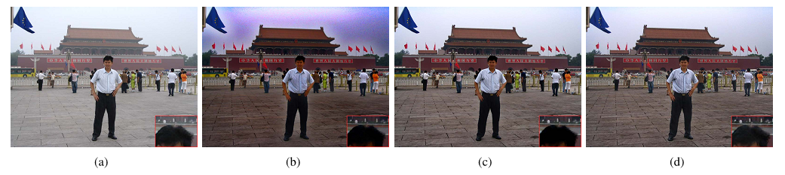

**Fig. 1. Comparison of the GIF, the WGIF and the G-GIF. (a) a haze image; (b) a dehazed image by the GIF; (c) a dehazed image by the WGIF; (d) a dehazed by the G-GIF. Both the GIF and the WGIF over smooth the hair of the human subject as illustrated in the zoom-in regions while the problem is overcome by the proposed G-GIF.**

The G-GIF is then applied to study single image haze removal. The proposed haze removal algorithm is based on the concepts of minimal color channel [19]–[21] and simplified dark channel in [9]. The simplified dark channel is decomposed into a base layer and a detail layer via the proposed G-GIF, and the base layer is used to estimate the transmission map. To avoid introducing artifacts to the dehazed image, the structure of the base layer (or the structure of the transmission map) is required to match the structure of the haze image. Since the structure of the haze image is preserved better by the minimal channel than the simplified dark channel [11], the minimal color channel is selected to generate the guidance vector field. Once the transmission map is estimated from the base layer, it can be used to recover the haze image. Experimental results show that the dehazed images by the proposed algorithm are sharper than those dehazed images by the algorithms in [7], [8], and [11]. It should be pointed out that the computational cost of the proposed algorithm is about the double of the algorithms in [7], [8], and [11]. Overall, there are two major contributions in this paper. One is the proposed G-GIF which preserves fine structures better than the GIF and WGIF. The other is a new single image haze removal algorithm based on the proposed G-GIF which can be applied to improve the sharpness of dehazed images.

The rest of this paper is organized as follows. Limitation of the GIF and WGIF is given in Section II. The detail of the proposed G-GIF is provided in Section III. Section IV includes an application of the proposed G-GIF in single image haze removal. Experimental results are given in Section V to illustrate the efficiency of the proposed haze removal algorithm. Concluding remarks are provided in Section VI.

**II. LIMITATION OF THE GIF AND WGIF**

In both the GIF [7] and the WGIF [9], a guidance image G is used which could be identical to the image X to be filtered. It is assumed that the output image Z ˆ is a linear transform of G in a predefined window ζ(p):



where ζ (p) is a square window centered at the pixel p of a radius ζ . ap and bp are two constants in the window ζ(p).

The values of a p and bp in the GIF [7] are then obtained by minimizing a cost function E(ap, bp) which is defined as

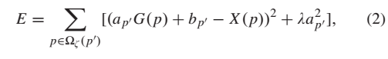

where λ is a regularization parameter penalizing large ap.

An edge-aware weighting G(p) is defined in the WGIF [9] by using local variances of 3 × 3 windows of all pixels as follows:

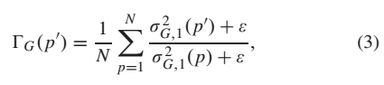

where ε is a small constant and its value is selected as (0.001× L)2 while L is the dynamic range of the input image.

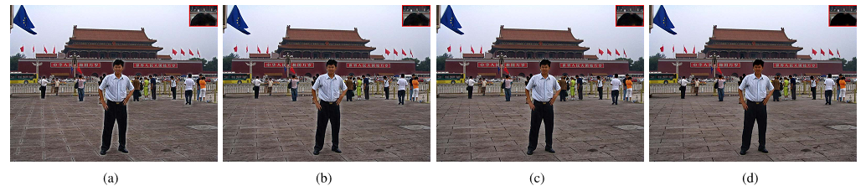

**Fig. 2. Limitation of the WGIF. (a) ζ = 7; (b) ζ = 15; (c) ζ = 30; and (d) ζ = 60. The morphological artifacts are reduced but the hair of the human subject becomes over smoothed if the value of ζ is increased.**

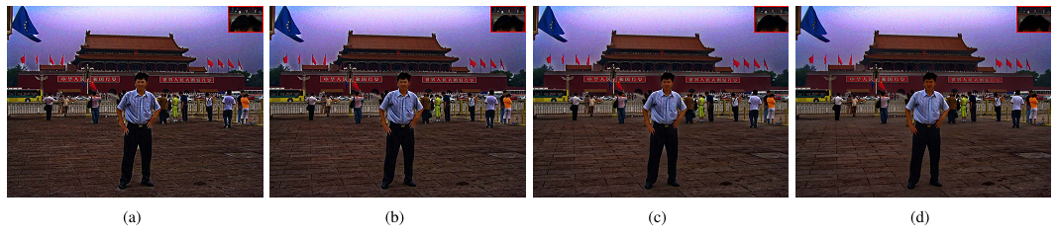

Fig. 3. Limitation of the GIF. (a) ζ = 7; (b) ζ = 15; (c) ζ = 30; and (d) ζ = 60. The morphological artifacts are reduced but the hair of the human subject becomes over smoothed if the value of ζ is increased.

The edge-aware weighting G(p) in Equation (3) is incorporated into the cost function E(ap, bp) in Equation (2). As such, the values of ap and bp in the WGIF [9] are then obtained by minimizing a new cost function E(ap, bp) which is defined as

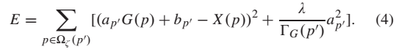

The optimal values of ap and bp are computed by solving the optimization problem (2) or the optimization problem (4). The output image Z ˆ (p) is finally given as follows: [9]



where a ¯ p and b ¯ p are the mean values of ap and bp in the window computed as

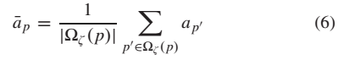

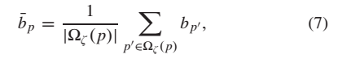

and |ζ (p)| is the cardinality of ζ (p).

As an illustration, both the GIF and the WGIF are applied to study single image haze removal. Four different choices of ζ are tested and they are 7, 15, 30, and 60. Readers are invited to view the electronic version of the full-size figures in order to better appreciate the differences among images. It is shown in Fig. 2 that the morphological artifacts are reduced if the value of ζ is increased. However, the hair of the human subject becomes smoothed or even over smoothed when the value of ζ is increased. The same phenomenon is observed for the GIF in Fig. 3. It is worth noting that the maximal filter is enabled for all the experimental results in Fig. 3. Here the maximal filter is obtained by replacing the minimal operation in the equation (21) by the maximal operation. It is shown in Fig. 4 that the morphological artifacts are indeed reduced by the maximal filter. Unfortunately, the hair of the human subject is further over-smoothed by it. The maximal filter is thus not enabled provided that it is specified in this paper. The WGIF is taken as example to show the effect of the average operations in the Equations (6) and (7). It is shown in Fig. 5 that the fine structures are preserved better while the morphological artifacts become more visible by disabling the average operations in the Equations (6) and (7). Clearly, both the GIF [7] and the WGIF [9] can over smooth images, especially in areas of fine structures. This is due to the large value of ζ and the average operations in the Equation (6) and (7). In the next subsection, a new G-GIF is proposed to address the problem.

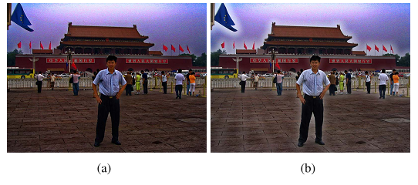

**Fig. 4. Effect of the maximal filter. (a) a dehazed image with the maximal filter; and (b) a dehazed image without the maximal filter. The morphological artifacts are reduced by the maximal filter but the hair of the human subject is further smoothed heavily.**

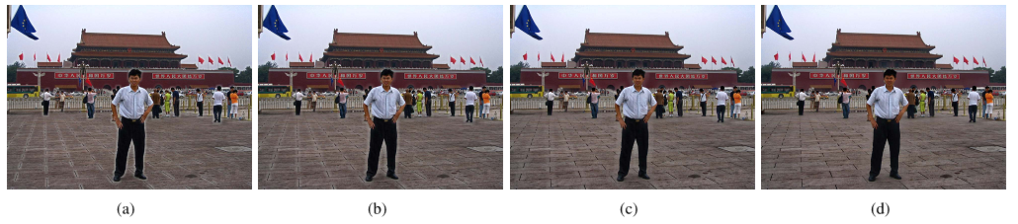

**Fig. 5. Dehazed images by the WGIF without the average operations (6) and (7). (a) ζ = 7; (b) ζ = 15; (c) ζ = 30; and (d) ζ = 60. The fine structures are preserved better by disabling the average operations (6) and (7) while the morphological artifacts become more visible.**

**Edge Preserving Smoothing Techniques:**

The task of edge-preserving smoothing is to crumble an image X into two parts as follows:



Where Ĵ is a reconstructed image formed by uniform regions with sharp edges, e is noise or texture, and p(=(x,y)) is a position. Ĵ and e are called base layer and detail layer, respectively. One of edge-preserving smoothing techniques is based on local filtering. Bilateral filter( BF) [3] is widely used due to its simplicity but suffer from “gradient reversal” artifacts usually observed in detail enhancement of conventional LDR images. Then GIF [14] was introduced to overcome this problem. In this GIF, a guidance image G was used which could be similar to the image X which is to be filtered. Ĵ is a linear transform of G in the window Ως (pʹ).To determine the linear coefficients (apʹ,bpʹ), a constraint is added to X and Ĵ as in Equation (1). The values of apʹ and bpʹ are then obtained by minimizing a cost function E(apʹ,bpʹ) which is defined as



Where λ is a regularization parameter. Another type of edge-preserving smoothing techniques was based on global optimization. The Weighted Least Square filter [8] was a typical example and it was derived by minimizing the following quadratic cost function:



Where N is the total number of pixels in an image. The two major differences between the WLS filter and the GIF. 1) The GIF [14] is based on local optimization while the WLS filter in based on global optimization. As such, the difficulty of the GIF is O(N) for an image with N number of pixels and the Weighted Least Square filter [8] is more complicated than the GIF. 2) The value of λ is fixed in the GIF while it is adaptive to local gradients in the WLS filter [8]. One possible problem for the GIF [14] is halos which could be reduced by the WLS filter. The spatial varying image gradients aware weighting λx(p)and λy(p) are very important for the WLS filter to avoid halo artifacts.

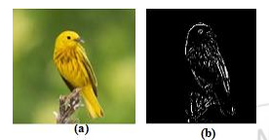

**Figure: a) Input image b) edge of input image**

**Guided Image Filter**

A general linear translation-variant filtering process, which involved a guidance image I, an filtering input image p, and an output image q. The filtering output at a pixel I was expressed as a weighted average:



Where i and j were pixel indexes. The filter kernel Wij was a function of the guidance image I and independent of p. This filter was linear with respect to p. The guided filter was a local linear model between the guidance I and the filtering output q. We assumed that q was a linear transform of I in a window!k centered at the pixel k:



Where (ak,bk) were some linear coefficients assumed to be constant in wk. A square window of a radius r was used. This local linear model ensures that q has an edge only if I had an edge, because 𝜵q=a𝜵I. The output q was modeled as the input p subtracting some unwanted components n like noise/textures:



**Adaptive Guided Image Filter**

An adaptive guided image filtering (AGF) [10] able to perform halo-free edge slope enhancement and noise reduction simultaneously. The intensity range domain of BLF and kernel function of GIF were similar in principle, because each of them takes the intensity value of center pixel p, local neighbors q and a smoothing parameter (σr in BLF, ε in GIF) in the computation process. This was based on the shifting technique of ABF, in which the offset ξp was added to the intensity value of center pixel pin the intensity range domain of BLF. The same strategy was applied to AGF - the offset is added to the intensity value of center pixel pin the kernel weights function of GIF.



It was effective to remove noise and sharpens the edges simultaneously, without producing overshoot and undershoot artifacts as the ideal approach. Disadvantage of AGF in terms of computation cost, where the computational complexity was O(N) compared to O(|w|2) of ABF.

**Chapter-2**

**LITERATURE SURVEY**

**Srinivasa G. Narasimhan and Shree K. Nayar,**

Conventional vision systems are designed to perform in clear weather. However, any outdoor vision system is incomplete without mechanisms that guarantee satisfactory performance under poor weather conditions. It is known that the atmosphere can significantly alter light energy reaching an observer. Therefore, atmospheric scattering models must be used to make vision systems robust in bad weather. In this paper, we develop a geometric framework for analyzing the chromatic effects of atmospheric scattering. First, we study a simple color model for atmospheric scattering and verify it for fog and haze. Then, based on the physics of scattering, we derive several geometric constraints on scene color changes, caused by varying atmospheric conditions. Finally, using these constraints we develop algorithms for computing fog or haze color, depth segmentation, extracting three dimensional structure, and recovering “true” scene colors, from two or more images taken under different but unknown weather conditions.

In this paper, we presented a general chromatic framework for scene understanding under bad weather conditions. Note that conventional image enhancement techniques are not useful here since the effects of weather must be modeled using atmospheric scattering principles that are closely tied to scene depth. We based our work on the simple yet useful dichromatic model. Several useful constraints on scene color changes due to different atmospheric conditions were derived. Using these constraints, we developed simple algorithms to recover the three dimensional structure and true colors of scenes, from images taken under poor weather conditions. These algorithms were demonstrated for both synthetic and real scenes

**Zhengguo Li, Jinghong Zheng, Zijian Zhu, Wei Yao and Shiqian Wu,**

It is known that local filtering-based edgepreserving smoothing techniques suffer from halo artifacts. In this paper, a weighted guided image filter (WGIF) is introduced by incorporating an edge-aware weighting into an existing guided image filter (GIF) to address the problem. The WGIF inherits advantages of both global and local smoothing filters in the sense that: 1) the complexity of the WGIF is O(N) for an image with N pixels, which is same as the GIF and 2) the WGIF can avoid halo artifacts like the existing global smoothing filters. The WGIF is applied for single image detail enhancement, single image haze removal, and fusion of differently exposed images. Experimental results show that the resultant algorithms produce images with better visual quality and at the same time halo artifacts can be reduced/avoided from appearing in the final images with negligible increment on running times.

A weighted guided image filter (WGIF) is proposed in this paper by incorporating an edge-aware weighting into the guided image filter (GIF). The WGIF preserves sharp edges as well as existing global filters, and the complexity of the WGIF is O(N) for an image with N pixels which is almost the same as the GIF. Due to the simplicity of the WGIF, it has many applications in the fields of computational photography and image processing. Particularly, it is applied to study single image detail enhancement, single image haze removal, and fusion of differently exposed images. Experimental results show that the resultant algorithms can produce images with excellent visual quality as those of global filters, and at the same time the running times of the proposed algorithms are comparable to the GIF based algorithms.

It should be pointed out that the ABFs in [15] and [16] appear to be similar to the WGIF. Unfortunately, as pointed out in [15], adaptation of the parameters will destroy the 3D convolution form, and the ABFs cannot be accelerated via the approach in [13]. While the WGIF preserves the simplicity of the GIF in [14]. On the other hand, it was shown in [10] and [36] that both the BF and the ABF can be easily extended to gradient domain while it is very challenging to extend the GIF and the WGIF to gradient domain.

It is noting that the WGIF can also be adopted to design a fast local tone mapping algorithm for high dynamic range images, joint upsampling, flash/no-flash de-noising, and etc. In addition, similar idea can be used to improve the anisotropic diffusion in [37], Poisson image editing in [6], etc. All these research problems will be studied in our future research.

**Qingsong Zhu, Jiaming Mai, Ling Shao,**

Single image haze removal has been a challenging problem due to its ill-posed nature. In this paper, we propose a simple but powerful color attenuation prior for haze removal from a single input hazy image. By creating a linear model for modeling the scene depth of the hazy image under this novel prior and learning the parameters of the model with a supervised learning method, the depth information can be well recovered. With the depth map of the hazy image, we can easily estimate the transmission and restore the scene radiance via the atmospheric scattering model, and thus effectively remove the haze from a single image. Experimental results show that the proposed approach outperforms state-of-the-art haze removal algorithms in terms of both efficiency and the dehazing effect.

In this paper, we have proposed a novel linear color attenuation prior, based on the difference between the brightness and the saturation of the pixels within the hazy image. By creating a linear model for the scene depth of the hazy image with this simple but powerful prior and learning the parameters of the model using a supervised learning method, the depth information can be well recovered. By means of the depth map obtained by the proposed method, the scene radiance of the hazy image can be recovered easily. Experimental results show that the proposed approach achieves dramatically high efficiency and outstanding dehazing effects as well. Although we have found a way to model the scene depth with the brightness and the saturation of the hazy image, there is still a common problem to be solved. That is, the scattering coefficient β in the atmospheric scattering model cannot be regarded as a constant in inhomogeneous atmosphere conditions [55]. For example, a region which is kilometers away from the observer should have a very low value of . Therefore, the dehazing algorithms which are based on the atmospheric scattering model are prone to underestimating the transmission in some cases. As almost all the existing single image dehazing algorithms are based on the constant- assumption, a more flexible model is highly desired. To overcome this challenge, some more advanced physical models [63] can be taken into account. We leave this problem for our future research.

**Lark Kwon Choi, Jaehee You, and Alan Conrad Bovik,**

We propose a referenceless perceptual fog density prediction model based on natural scene statistics (NSS) and fog aware statistical features. The proposed model, called Fog Aware Density Evaluator (FADE), predicts the visibility of a foggy scene from a single image without reference to a corresponding fog-free image, without dependence on salient objects in a scene, without side geographical camera information, without estimating a depth-dependent transmission map, and without training on human-rated judgments. FADE only makes use of measurable deviations from statistical regularities observed in natural foggy and fog-free images. Fog aware statistical features that define the perceptual fog density index derive from a space domain NSS model and the observed characteristics of foggy images. FADE not only predicts perceptual fog density for the entire image, but also provides a local fog density index for each patch. The predicted fog density using FADE correlates well with human judgments of fog density taken in a subjective study on a large foggy image database. As applications, FADE not only accurately assesses the performance of defogging algorithms designed to enhance the visibility of foggy images, but also is well suited for image defogging. A new FADE-based referenceless perceptual image defogging, dubbed DEnsity of Fog Assessmentbased DEfogger (DEFADE) achieves better results for darker, denser foggy images as well as on standard foggy images than the state of the art defogging methods. A software release of FADE and DEFADE is available online for public use: <http://live.ece.utexas.edu/research/fog/index.html>.

We have described a prediction model of perceptual fog density called FADE and a perceptual image defogging algorithm dubbed DEFADE, both based on image NSS and fog aware statistical features. FADE predicts the degree of visibility of a foggy scene from a single image, while DEFADE enhances the visibility of a foggy image without any reference information such as multiple foggy images of the same scene, different degrees of polarization, salient objects in the foggy scene, auxiliary geographical information, a depthdependent transmission map, content oriented assumptions, and even without training on human-rated judgments. FADE utilizes only measurable deviations from statistical regularities observed in natural foggy and fog-free images. We detailed the model and the fog aware statistical features, and demonstrated how the fog density predictions produced by FADE correlate well with human judgments of fog density taken in a subjective study on a large foggy image database. As an application, we validated that FADE can be a useful, NR tool for evaluating the performance of defogging algorithms. Lastly, we demonstrated that a FADE based, referenceless perceptual image defogging algorithm DEFADE achieves better results on darker, denser foggy images as well as on standard defog test images than state of the art defogging algorithms. Future work could involve developing hardware friendly versions of DEFADE suitable for integrated circuit implementation and the development of mobile image defogging apps.

**Kaiming He, Jian Sun, and Xiaoou Tang,**

In this paper, we propose a simple but effective image prior—dark channel prior to remove haze from a single input image. The dark channel prior is a kind of statistics of outdoor haze-free images. It is based on a key observation—most local patches in outdoor haze-free images contain some pixels whose intensity is very low in at least one color channel. Using this prior with the haze imaging model, we can directly estimate the thickness of the haze and recover a high-quality haze-free image. Results on a variety of hazy images demonstrate the power of the proposed prior. Moreover, a high-quality depth map can also be obtained as a byproduct of haze removal.

In this paper, we have proposed a very simple but powerful prior, called the dark channel prior, for single image haze removal. The dark channel prior is based on the statistics of outdoor haze-free images. Combining the prior with the haze imaging model, single image haze removal becomes simpler and more effective. Since the dark channel prior is a kind of statistics, it may not work for some particular images. When the scene objects are inherently similar to the atmospheric light and no shadow is cast on them (such as the white marble in Fig. 18), the dark channel prior is invalid. The dark channel of the scene radiance has bright values near such objects. As a result, our method will underestimate the transmission of these objects and overestimate the haze layer. Moreover, as our method depends on the haze imaging model (1), it may fail when this model is physically invalid. First, the constant-airlight assumption may be unsuitable when the sunlight is very influential. In Fig. 19a, the atmospheric light is bright on the left and dim on the right. Our automatically estimated A (Fig. 19c) is not the real A in the other regions, so the recovered sky region on the right is darker than it should be (Fig. 19b). More advanced models [14] can be used to describe this complicated case. Second, the transmission t is wavelength dependent if the particles in the atmosphere are small (i.e., the haze is thin) and the objects are kilometers away [7]. In this situation, the transmission is different among color channels. This is why the objects near the horizon appear bluish (Fig. 19a). As the haze imaging model (1) assumes common transmission for all color channels, our method may fail to recover the true scene radiance of the distant objects and they remain bluish. We leave this problem for future research.

**pat s. chavez, jr,**

Digital analysis of remotely sensed data has become an important component of many earth-science studies. These data are often processed through a set of preprocessing or "clean-up" routines that includes a correction for atmospheric scattering, often called haze. Various methods to correct or remove the additive haze component have been developed, including tho "-",~elyused dark-object subtraction technique. A problem with most o1 these methods is that the haze values for each spectral band are selected independently. This can create problems because atmospheric scattering is highly wavelength-dependent in the visible part of the electromagnetic spectrum and the scattering values are correlated with each other. Therefore, multispectral data such as from the Landsat Thematic Mapper and Multispectral Scanner must be corrected with haze values that are spectral band dependent. An improved dark-object subtraction technique is demonstrated that allows the user to select a relative atmospheric scattering model to predict the haze values for all the spectral bands from a selected starting band haze value. The improved method normalizes the predicted haze values for the different gain and offset parameters used by the imaging system. Examples of haze value dif|erenees between the old and improved methods for Thematic Mapper Bands 1, 2, 3, 4, 5, and 7 are 40.0, 13.0, 12.0, 8.0, 5.0, and 2.0 vs. 40.0, 13.2, 8.9, 4.9, 16.7, and 3.3, respectively, using a relative scattering model of a clear atmosphere. In one Landsat multispectral scanner image the haze value differences for Bands 4, 5, 6, and 7 were 30.0, 50.0, 50.0, and 40.0 for the old method vs. 30.0, 34.4, 43.6, and 6.4 for the new method using a relative scattering model o£ a hazy atmosphere.

A method has been developed that allows atmospheric scattering parameters to be generated so that their DN values conform to a user-selected relative scattering model. The computed haze values, which are wavelength-dependent and correlated to each other, can be used after proper gain and offset normalization to apply a simple dark-object subtraction to remotely sensed multispectral image data to correct for atmospheric scattering. In this study the relative scattering models used were power law models where the power used was based on the amplitude of the starting haze value. Other possible relative scattering models could be used. The critical aspect of this technique is to use DN values that conform to some realistic relative scattering model so that the haze values will be wavelength-dependent and correlated with each other.

The haze corrections can be applied to the original data in DN counts of the imaging system. However, the user can, if desired, convert the entire image to radiance units before correcting for haze. But normalizing the predicted haze values for gain and offset allows the corrections to be applied without having to convert an entire image's DNs into radiance values. This does not imply that it is better to use the DN counts, but that an optional way exists to accomplish the improved correction without having to convert the entire image to radiance values.

This type of correction is important if remotely sensed data are to be exploited to their maximum potential. Studies dealing with analyses of the spectral response of cover types, temporal studies, and signature extension (temporally and spatially) have to be able to correct or remove variable factors, such as atmospheric scattering, from the data which have nothing to do with the information of interest. Research is currently under way to establish a better relationship between the starting haze value and the type of atmospheric conditions present during data collection.

**Raanan Fattal, Dani Lischinski, Michael Werman,**

We present a new method for rendering high dynamic range images on conventional displays. Our method is conceptually simple, computationally efficient, robust, and easy to use. We manipulate the gradient field of the luminance image by attenuating the magnitudes of large gradients. A new, low dynamic range image is then obtained by solving a Poisson equation on the modified gradient field. Our results demonstrate that the method is capable of drastic dynamic range compression, while preserving fine details and avoiding common artifacts, such as halos, gradient reversals, or loss of local contrast. The method is also able to significantly enhance ordinary images by bringing out detail in dark regions.

We have described a new, simple, computationally efficient, and robust method for high dynamic range compression, which makes it possible to display HDR images on conventional displays. Our method attenuates large gradients and then constructs a low dynamic range image by solving a Poisson equation on the modified gradient field.

Future work will concentrate on the many different exciting possible applications of the construction of an image from modified gradient fields. Preliminary results show promise in denoising, edge manipulation and non-photorealistic rendering from real images. In addition, we would like to extend our work so as to incorporate various psychophysical properties of human visual perception in order to make our technique more useful for applications such as lighting design or visibility analysis.

**Fei Kou, Weihai Chen, Changyun Wen, Zhengguo Li,**

Guided image filter (GIF) is a well-known local filter for its edge-preserving property and low computational complexity. Unfortunately, the GIF may suffer from halo artifacts because the local linear model used in the GIF cannot represent the image well near some edges. In this paper, a gradient domain guided image filter is proposed by incorporating an explicit first-order edge-aware constraint. The edge-aware constraint makes edges be preserved better. To illustrate efficiency of the proposed filter, the proposed gradient domain guided image filter is applied for single image detail enhancement, tone mapping of high dynamic range (HDR) images and image saliency detection. Both theoretical analysis and experimental results prove that the proposed gradient domain guided image filter can produce better resultant images, especially near the edges where halos appear in the original GIF.

In this paper, a new gradient domain guided image filter has been proposed by incorporating an explicit first-order edge-aware constraint into the existing guided image filter. Experimental results of image detail enhancement and HDR image tone mapping show that the proposed filter produces images with better visual appearance than the existing guided filter based algorithms, especially around edges. In addition, based on the new filter, a new saliency detection postprocessing method has been proposed, which can make the saliency detection algorithms more accurate. It is reported in [10] that there are many applications of guided image filter such as the Flash/no-flash, RGB/NIR, dark-flash image restoration applications. We believe that the proposed filter is also applicable to those applications. One more interesting problem is on the extension of the proposed filter so as to extract fine details from multiple images simultaneously by the extended filter as in [44], [45]. They will be studied in our future research.

**Jaesik Park, Hyeongwoo Kim, Yu-Wing Tai, Michael S. Brown, Inso Kweon,**

This paper describes an application framework to perform high quality upsampling on depth maps captured from a low-resolution and noisy 3D time-of-flight (3D-ToF) camera that has been coupled with a high-resolution RGB camera. Our framework is inspired by recent work that uses nonlocal means filtering to regularize depth maps in order to maintain fine detail and structure. Our framework extends this regularization with an additional edge weighting scheme based on several image features based on the additional high-resolution RGB input. Quantitative and qualitative results show that our method outperforms existing approaches for 3D-ToF upsampling. We describe the complete process for this system, including device calibration, scene warping for input alignment, and even how the results can be further processed using simple user markup.

We have presented a framework to upsample a lowresolution depth map from the 3D-ToF camera using an auxiliary high-resolution RGB image. Our framework is based on a least-square optimization that combines several weighting factors together with nonlocal means filtering to maintain sharp depth boundaries and to prevent depth bleeding during propagation. Although this work is admittedly more engineering in nature, we believe it provides useful insight on various weighting strategies for those working with noisy range senors. Moreover, experimental result show that our results typically out performs previous work in terms of both RMSE and visual quality. In addition to the automatic method, we have also discussed how to extend our approach to incorporate user markup.

**Robby T. Tan,**

Bad weather, such as fog and haze, can significantly degrade the visibility of a scene. Optically, this is due to the substantial presence of particles in the atmosphere that absorb and scatter light. In computer vision, the absorption and scattering processes are commonly modeled by a linear combination of the direct attenuation and the airlight. Based on this model, a few methods have been proposed, and most of them require multiple input images of a scene, which have either different degrees of polarization or different atmospheric conditions. This requirement is the main drawback of these methods, since in many situations, it is difficult to be fulfilled. To resolve the problem, we introduce an automated method that only requires a single input image. This method is based on two basic observations: first, images with enhanced visibility (or clear-day images) have more contrast than images plagued by bad weather; second, airlight whose variation mainly depends on the distance of objects to the viewer, tends to be smooth. Relying on these two observations, we develop a cost function in the framework of Markov random fields, which can be efficiently optimized by various techniques, such as graph-cuts or belief propagation. The method does not require the geometrical information of the input image, and is applicable for both color and gray images.

For future work, we intend to concentrate on the current constraints of our method. First is the halos at depth discontinuities. One can observe, for instance in Figure 9, there are some small halos surrounding the trees in the image. We suspect that it is due to the patch-based operation we use; and, this problem should be straighforward to solve if we know the depth discontinuities of the scenes (which, in the input image, are obscured by the atmospheric particles). The second constraint is that, since we optimize the data cost function and do not know the actual values of A, the outputs tend to have larger saturation values (of huesaturation-intensity) than those in the actual clear-day images. To overcome this, we intend to incorporate the observation 3 in Section 4, namely that the outputs must follow the characteristics of natural images of clear-day scenes. We hypothesize that these characteristics can be learned statistically. Finally, we also intend to apply the proposed methodFigure 11. Top: input image. Second from top: the direct attenuation. Third from the top: the ground truth. Bottom: the airlight. Note that, we increase the intensity of the direct attenuation, since the input image is considerably darker than the ground truth. to improve under-water visibility [9] or other turbid media that have the same optical model.

As a conclusion, we have introduced a method that is solely based on single images, without requiring the geometrical structure of the world nor any user interactions. We believe that many applications, such as outdoor surveillance systems, intelligent vehicle systems, remote sensing systems, graphics editors, etc, could benefit from our proposed method.

**Chapter-3**

**PROPOSED WORK**

**GLOBALLY GUIDED IMAGE FILTERING**

Inspired by the GIF in [7], the WGIF in [9], the gradient domain image processing algorithms in [10], [13], and [14], the WLS filter in [16] and the quadratic optimization problem in [17], a new type of GIFs is proposed in this section. Unlike the GIF in [7] and the WGIF in [9], the proposed filter is a global filter and it is thus called the G-GIF. Inputs of the proposed G-GIF are an image to be filtered and a guidance vector field while inputs of the GIF and WGIF are an image to be filtered and a guidance image. The structure is defined by the guidance vector field. The proposed G-GIF is composed of a global structure transfer filter and a global edge-preserving smoothing filter. The function of the structure transfer filter is to transfer the predefined structure to the image to be filtered while the function of the smoothing filter is to smooth the transferred image so as to produce the output image.

The structure transfer filter is inspired by the GIF in [7], the WGIF in [9], and the gradient domain image processing algorithms in [10], [13], and [14]. The inputs of the structure transfer filter are an image to be filtered and a guidance vector field. The structure to be transferred is defined by the the guidance vector field. The objective of the structure transfer filter is to transfer the structure to the image to be filtered. The structure transfer filter is formulated as a global optimization problem. The cost function is composed of two terms. One term is in image domain and it measures the fidelity of the output image to the image to be filtered. The other is in gradient domain and it specifies the structure of the output image. The former is defined as



where X is an image to be filtered. The term E1(O, X) implies that the output image O is required to approximate the image to be filtered as much as possible.

Let V = (V h, V v ) be the guidance vector field. The latter is defined as



where ∇ O is the gradient field of the output image O. The term E2(O, V ) means that the structure of the output image O matches the guidance vector filed as much as possible [14].

The overall cost function is computed as



where λ is a non-negative constant and its function is to obtain a trade-off between the two terms.

It should be pointed out that 1) the proposed cost function E(O) is the same as the cost function in [14] if the value of λ is 0; and 2) the proposed cost function E(O) is similar to the cost function in [17] when all pixel values in the input image are zeros. This implies that the cost functions in [14] and [17] can be regarded as special cases of the proposed cost function.

Using matrix notation, the cost function E(O) can be rewritten as

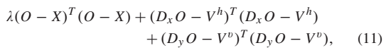

where the matrices D x and Dy are discrete differentiation operators.

The vector O that minimizes the cost function is uniquely defined as the solution of the linear equation



where I is an identity matrix. It can be easily verified that the matrix (λI + Dx T Dx + DT y Dy) is non-singular if λ is positive while the matrix (Dx T Dx + DT y Dy) is singular. Thus, a fast separating method like the method in [18] is applicable to solve the above linear equation due to the non-singularity of the matrix (λI + Dx T Dx + DT y Dy) with a positive λ. However, the separating method in [18] is not applicable if the value of λ is 0. This is because that the matrix (Dx T Dx + DT y Dy) is singular. Thus, it is much easier to solve the proposed optimization problem based on the cost function (10) than the optimization problem in [14].

As an illustration, the structure transfer filter is applied to estimate the transmission map of a haze image. As shown in Fig. 6, the structure of the haze image is indeed transferred to the simplified dark channel by the structure transfer filter. Even though the structure of the vector field V is transferred into the output image O∗ by the structure transfer filter, the output image O∗ sometimes needs to be smoothed. An example is given in Fig. 7. Clearly, the quality of the dehazed image is significantly dropped if the output image O∗ is not smoothed. To achieve the objective, the output image O∗ is decomposed into two layers via an edgepreserving smoothing filter. Inspired by the WLS filter in [16] and the quadratic optimization problem in [17], a new edgepreserving smoothing filter is formulated as

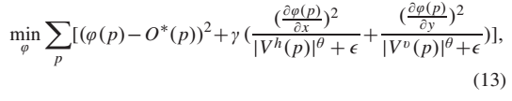

where γ , θ, and are three constants.

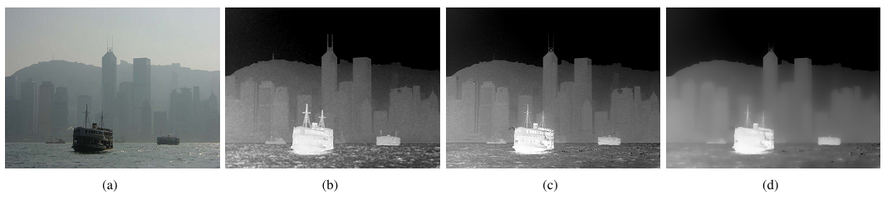

**Fig. 6. Illustration of the proposed G-GIF by using it to estimate the transmission map of a haze image. (a) a haze image; (b) simplified dark channel of the normalized haze image which is the image to be filtered; (c) output image of the structure transfer filter; and (d) output image of the proposed G-GIF.**

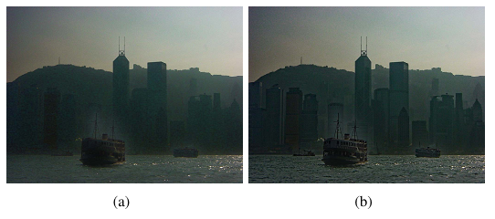

**Fig. 7. Effect of the global edge-preserving smoothing filter. (a) a dehazed image without the smoothing filter (13); (b) a dehazed image with the smoothing filter (13).**

As shown in the Equation (13), the inputs of the edgepreserving smoothing filter are an image to be smoothed and a vector field. It can be easily checked that when the vector field is given by



the proposed cost function in Equation (13) is the same as the cost function in [16]. This implies that the WLS filter in [16] is a special case of the proposed one.

Similarly, using the matrix notation, the above cost function can be rewritten as



where the matrices B x and By are given as

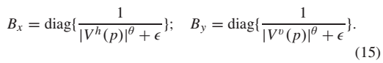

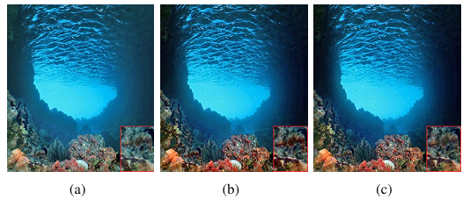

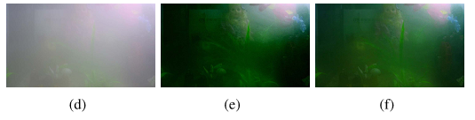

**Fig. 8. Two images and their enhanced images via two different decomposition models. (a) an underwater image; (b) an enhanced image via the decomposition model in [11]; and (c) an enhanced image via the proposed model. (d) a haze image; (e) an enhanced image via the decomposition model in [11]; and (f) an enhanced image via the proposed model. The color is slightly over-saturated by the model in [11].**

The vector ϕ that minimizes the cost function is uniquely defined as the solution of the linear equation



Similarly, by using a fast separate method like the method in [18], the above linear equation can be solved very fast. As shown in [18], the speed of the fast WLS is almost the same as those of the GIF in [7] and the WGIF in [9]. The speeds of both the proposed structure filter and the edge-preserving smoothing filter are comparable to the speed of the fast WLS. Therefore, the complexity of the proposed G-GIF is about the double of the GIF in [7] and the WGIF in [9]. In the next section, the proposed G-GIF will be applied to design a single image haze removal algorithm.

**SINGLE IMAGE HAZE REMOVAL VIA THE G-GIF**

In this section, a simple single image haze removal algorithm is introduced by using the proposed G-GIF and the Koschmiedars law [22]. The global atmospheric light A c(c ∈ {r, g, b}) is empirically determined by using a hierarchical searching method based on the quad-tree subdivision [23]. The value of the transmission map t(p) is then estimated by using the proposed G-GIF. Finally, the scene radiance Z(p) is recovered.

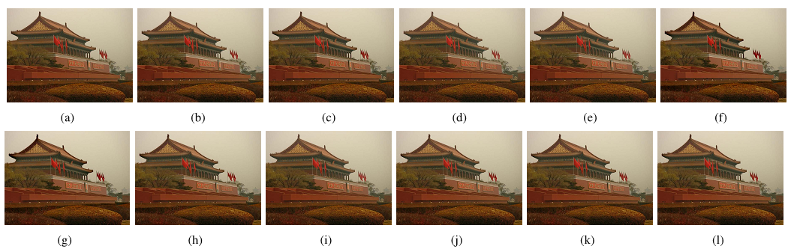

**Fig. 9. Different choices of λ in the equation (24) as well as γ , θ, and in the equation (25). (a) λ = 1/2048; (b) λ = 1/512; (c) λ = 1/8192; (d) γ = 512; (e) γ = 1024; (f) γ = 8192; (g) θ = 1; (h) θ = 1.5; (i) θ = 2; (j) = 1/32; (k) = 1/128; and (l) = 1/256.**

According to the Koschmiedars law [22], a haze image is generally modeled by



where c ∈ {r, g, b} is a color channel index, Xc is a haze image, Zc is a haze-free image, Ac is the global atmospheric light, and t is the medium transmission describing the portion of the light that is not scattered and reaches the camera.

Unlike the decomposition model in [11], it is assumed that the values of Ar, Ag and Ab are estimated before the simplified dark channel is computed. Fortunately, this is not problem by using the method in [23] to estimate the values of Ar, Ag and Ab. It should be pointed out that the methods in [6], [7], and [9] are not applicable because the global atmospheric light is needed to estimate before the dark channel is computed.

A simple haze image model is derived by using the simplified dark channels of the normalized haze image X/A and the normalized haze-free image Z/A. Let X ˜ m(p) and Z ˜ m(p) be defined as

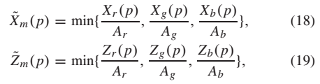

X m and Z ˜ m are called the minimal color components of the images X A and Z A , respectively [11], [19]–[21]. Since the transmission map t(p) is independent of the color channels r, g, and b, it can be derived from the haze image model in Equation (17) that the relationship between the minimal color components X ˜ m and Z ˜ m is given as



Let ζ (p) be a square window centered at the pixel p of a radius ζ . The simplified dark channels of the normalized images X A and Z A are then defined as

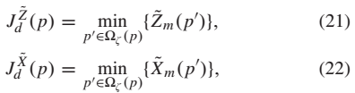

where the value of ζ is fixed at 7 in this paper.

Since the value of t(p) is usually constant in the neighborhood ζ (p), it can be derived from Equation (20) that



Compared with the decomposition model in [11], the model in the Equation (23) can be applied to improve the robustness of single image haze removal algorithm as shown in Fig. 8. For example, the color is slightly over-saturated by the model in [11] as shown in Fig. 8(e) and the zoom-in region in Fig. 8(b). The problem is overcome by the proposed decomposition model as illustrated in Fig. 8(f) and the zoom-in region in Fig. 8(c).

The image to be filtered is JdX ˜ and the guidance vector field is defined as ∇ X ˜ m. The structure of ∇ X ˜ m is transferred to the image JdX ˜ via



where the value of λ is selected as 1/2048 for all the experimental results in this paper provided that its value is specified.

The output image O∗ is further smoothed as

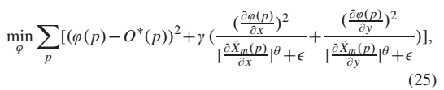

where the values of γ , θ, and are respectively selected as 2048, 13/8, and 1/64 for all the experimental results in this paper provided that their values are specified.

The optimal value of the transmission map t(p) is then computed as



Similar to the algorithm in [11], the proposed algorithm includes an adaptive sky-region compensation term to detect sky region in a haze image. The value of transmission map is further tuned in the sky region to avoid amplifying noise in the sky region.

Finally, the scene radiance Z(p) is recovered by

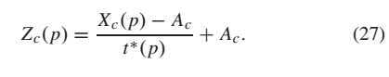

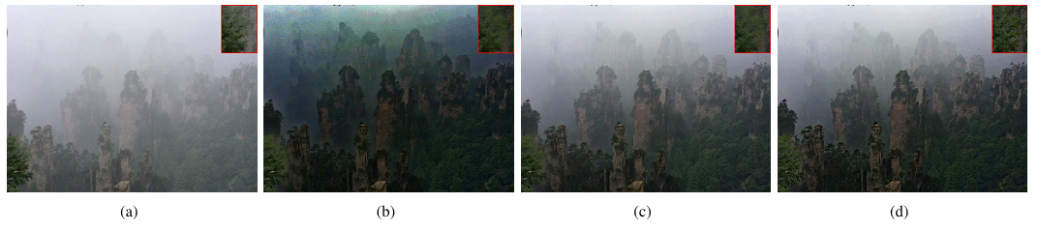

**Fig. 10. Comparison of the proposed G-GIF with the GIF in [7] and the WGIF in [9]. (a) a hazed image; (b) a de-hazed image by the GIF in [7]; (c) a de-hazed images by the WGIF in [9]; (d) a de-hazed image by the proposed G-GIF. The proposed G-GIF preserves the structure of branches and leafs better than the GIF and WGIF.**

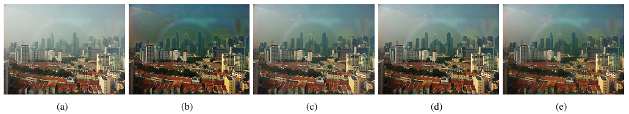

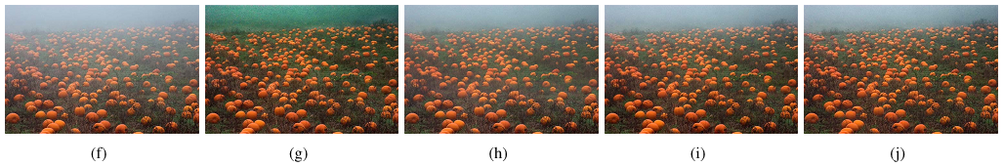

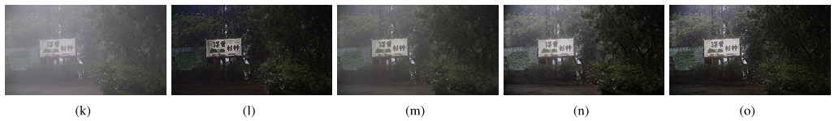

**Fig. 11. Comparison of the proposed haze removal algorithm and the haze removal algorithms in [7], [8], and [11] via three haze images. (a, f, k) three images with haze; (b, g, l) de-hazed images by the algorithm in [7]; (c, h, m) de-hazed images by the algorithm in [8]; (d, i, n) de-hazed images by the algorithm in [11]; (e, j, o) de-hazed images by the proposed algorithm.**

**Chapter-4**

**EXPERIMENTAL RESULTS**

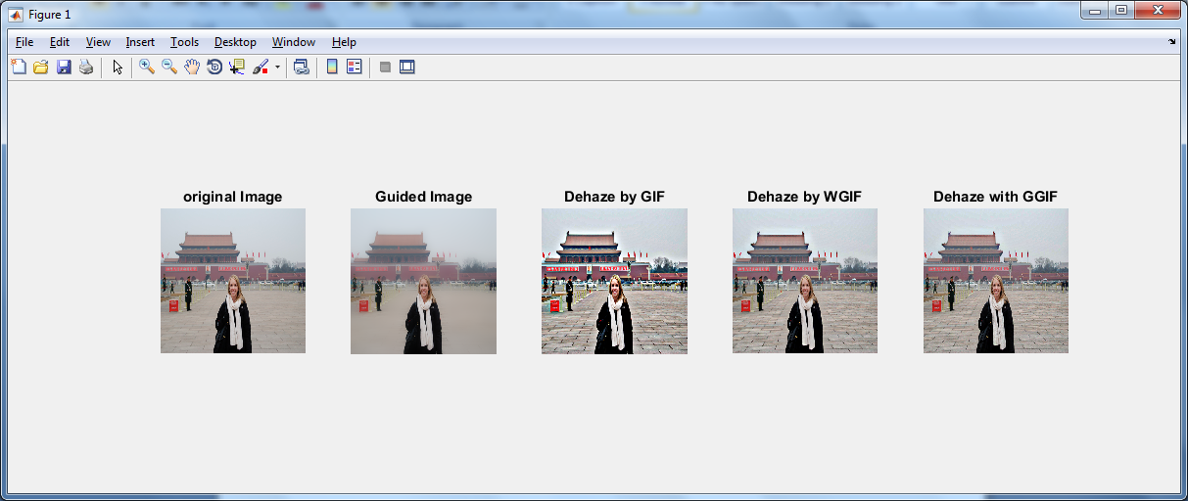

**Fig. 1. Comparison of the GIF, the WGIF and the G-GIF. (a) a haze image; (b) a dehazed image by the GIF; (c) a dehazed image by the WGIF; (d) a dehazed by the G-GIF. Both the GIF and the WGIF over smooth the hair of the human subject as illustrated in the zoom-in regions while the problem is overcome by the proposed G-GIF.**

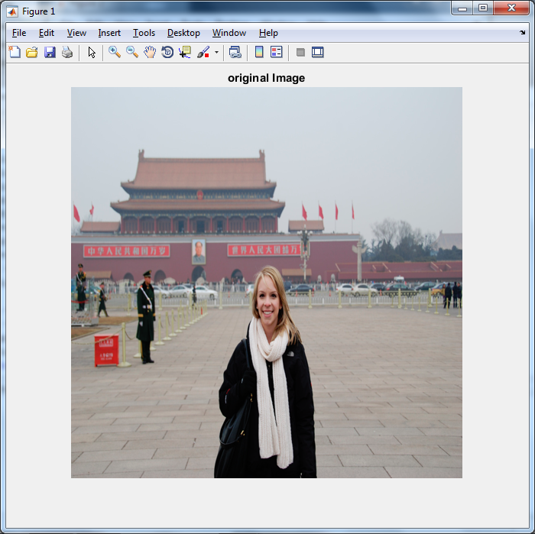

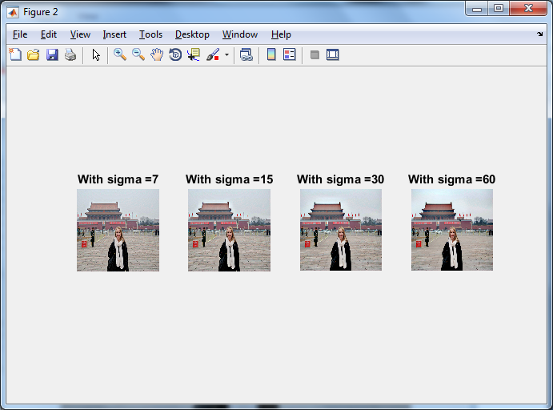

**Fig. 2. Limitation of the WGIF. (a) ζ = 7; (b) ζ = 15; (c) ζ = 30; and (d) ζ = 60. The morphological artifacts are reduced but the hair of the human subject becomes over smoothed if the value of ζ is increased.**

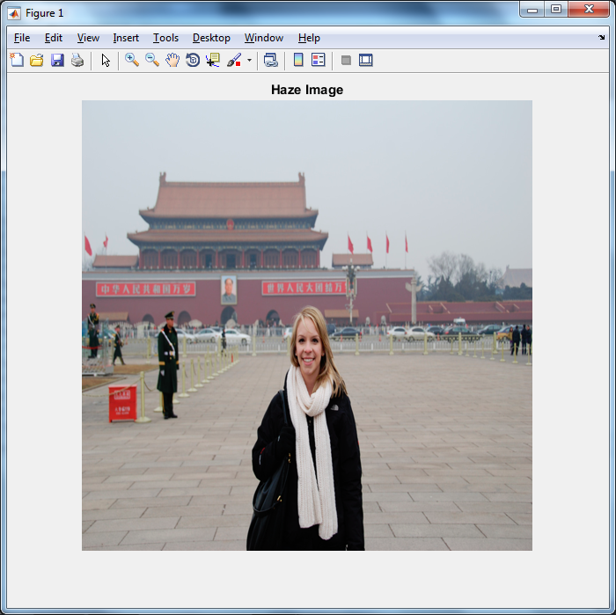

**Fig.3(a) a haze image**

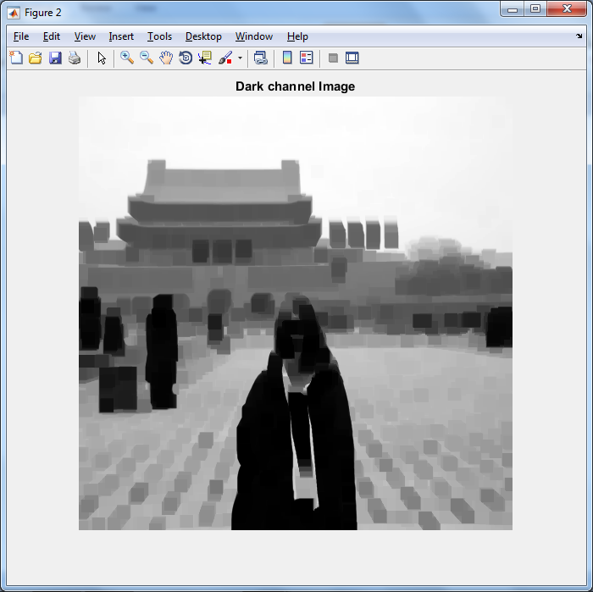

**Fig.3(b) simplified dark channel of the normalized haze image which is the image to be filtered**

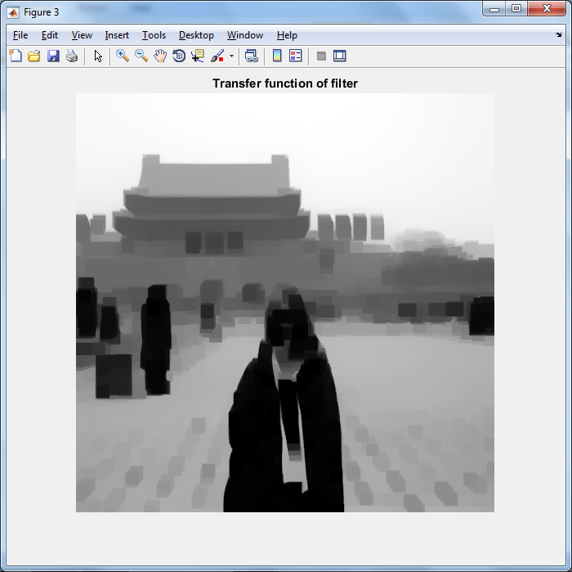

**Fig.3(c) output image of the structure transfer filter**

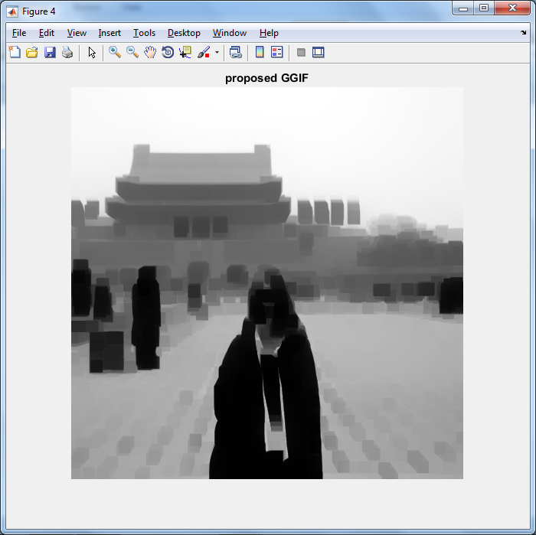

**Fig.3(d) output image of the proposed G-GIF.**

**Fig.3. Illustration of the proposed G-GIF by using it to estimate the transmission map of a haze image. (a) a haze image; (b) simplified dark channel of the normalized haze image which is the image to be filtered; (c) output image of the structure transfer filter; and (d) output image of the proposed G-GIF.**

**Chapter-5**

**CONCLUSION AND DISCUSSION**

A new globally guided image filtering is introduced in this paper. The proposed filter can be applied to produce sharper images and preserves details in regions of fine structure visibly better than the existing locally guided image filtering. It is applied to study single image haze removal. Experimental results demonstrate that the proposed haze removal algorithm indeed improves visual quality of dehazed images.

Besides single image haze removal, there are many applications of the proposed filters. For example, the filter can be applied to study panorama imaging [24], edge-aware smoothing pyramid for exposure fusion [25], detail enhancement, image matting, HDR compression, feathering, high resolution up-sampling, and so on. We will study these applications in our future research.

**REFERENCES**

[1] L. K. Choi, J. You, and A. C. Bovik, “Referenceless prediction of perceptual fog density and perceptual image defogging,” IEEE Trans. Image Process., vol. 24, no. 11, pp. 3888–3901, Nov. 2015.

[2] S. G. Narasimhan and S. K. Nayar, “Chromatic framework for vision in bad weather,” in Proc. IEEE Conf. Comput. Vis. Pattern Recognit. (CVPR), Hilton Head Island, SC, USA, Jun. 2000, pp. 598–605.

[3] R. Tan, “Visibility in bad weather from a single image,” in Proc. IEEE Conf. Comput. Vis. Pattern Recognit. (CVPR), Anchorage, AK, USA, Jun. 2008, pp. 1–8.

[4] R. Fattal, “Single image dehazing,” in Proc. SIGGRAPH, New York, NY, USA, Jun. 2008, pp. 1–9.

[5] P. S. Chavez, “An improved dark-object subtraction technique for atmospheric scattering correction of multispectral data,” Remote Sens. Environ., vol. 24, no. 3, pp. 459–479, Apr. 1988.

[6] K. He, J. Sun, and X. Tang, “Single image haze removal using dark channel prior,” IEEE Trans. Pattern Anal. Mach. Intell., vol. 33, no. 12, pp. 2341–2353, Dec. 2011.

[7] K. He, J. Sun, and X. Tang, “Guided image filtering,” IEEE Trans. Pattern Anal. Mach. Intell., vol. 35, no. 6, pp. 1397–1409, Jun. 2013.

[8] Q. Zhu, J. Mai, and L. Shao, “A fast single image haze removal algorithm using color attenuation prior,” IEEE Trans. Image Process., vol. 24, no. 11, pp. 3522–3533, Nov. 2015.

[9] Z. Li, J. Zheng, Z. Zhu, W. Yao, and S. Wu, “Weighted guided image filtering,” IEEE Trans. Image Process., vol. 24, no. 1, pp. 120–129, Jan. 2015.

[10] F. Kou, W. Chen, C. Wen, and Z. Li, “Gradient domain guided image filtering,” IEEE Trans. Image Process., vol. 24, no. 11, pp. 4528–4539, Nov. 2015.

[11] Z. Li and J. Zheng, “Edge-preserving decomposition-based single image haze removal,” IEEE Trans. Image Process., vol. 24, no. 12, pp. 5432–5441, Dec. 2015.

[12] J. Park, H. Kim, Y. W. Tai, M. S. Brown, and I. Kweon, “High quality depth map upsampling for 3D-TOF cameras,” in Proc. IEEE Int. Conf. Comput. Vis., Colorado Springs, CO, USA, Jun. 2011, pp. 1623–1630.

[13] R. Fattal, D. Lischinski, and M. Werman, “Gradient domain high dynamic range compression,” ACM Trans. Graph., vol. 27, no. 3, pp. 67-1–67-10, Jul. 2002.

[14] P. Pérez, M. Gangnet, and A. Blake, “Poisson image editing,” ACM Trans. Graph., vol. 22, no. 3, pp. 313–318, Jul. 2003.

[15] E. S. L. Gastal and M. M. Oliveira, “Domain transform for edgeaware image and video processing,” ACM Trans. Graph., vol. 30, no. 4, Jul. 2011, Art. no. 69.

[16] Z. Farbman, R. Fattal, D. Lischinshi, and R. Szeliski, “Edge-preserving decompositions for multi-scale tone and detail manipulation,” ACM Trans. Graph., vol. 27, no. 3, p. 67, Aug. 2008.

[17] Z. G. Li, J. H. Zheng, and S. Rahardja, “Detail-enhanced exposure fusion,” IEEE Trans. Image Process., vol. 21, no. 11, pp. 4672–4676, Nov. 2012.

[18] D. Min, S. Choi, J. Lu, B. Ham, K. Sohn, and M. Do, “Fast global image smoothing based on weighted least squares,” IEEE Trans. Image Process., vol. 23, no. 12, pp. 5638–5653, Dec. 2014.

[19] J.-P. Tarel and N. Hautiere, “Fast visibility restoration from a single color or gray level image,” in Proc. IEEE Conf. Comput. Vis. Pattern Recognit., Kyoto, Japan, Sep./Oct. 2009, pp. 2201–2208.

[20] S. Kang, W. Bo, Z. Zhihui, and Z. Zhiqiang, “Fast single image dehazing using iterative bilateral filter,” in Proc. Int. Conf. Inf. Eng. Comput. Sci., Wuhan, China, Dec. 2010, pp. 1–4.

[21] C. Xiao and J. Gan, “Fast image dehazing using guided joint bilateral filter,” Vis. Comput., vol. 28, nos. 6–8, pp. 713–721, Jun. 2012.

[22] H. Koschmider, “Theorie der horizontalen sichtweite,” Contrib. Phys. Free Atmos., vol. 12, pp. 171–181, 1924.

[23] J.-H. Kim, W.-D. Jang, J.-Y. Sim, and C.-S. Kim, “Optimized contrast enhancement for real-time image and video dehazing,” J. Vis. Commun. Image Represent., vol. 24, no. 3, pp. 410–425, Apr. 2013.

[24] W. Yao and Z. Li, “Instant color matching for mobile panorama imaging,” IEEE Signal Process. Lett., vol. 22, no. 1, pp. 6–10, Jan. 2015.

[25] Z. Li, Z. Wei, C. Wen, and J. Zheng, “Detail-enhanced multi-scale exposure fusion,” IEEE Trans. Image Process., vol. 26, no. 3, pp. 1243–1252, Mar. 2017.

**APPENDIX-I**

**MATLAB**

**1 INTRODUCTION**

MATLAB is a tip pinnacle tongue for precise making ready .It organizes figuring belief and in addition programming in a easy to make use of condition. Tangle lab stays for grid observe focus. It changed into shaped at the start to give direct get right of entry to to prepare programming made by way of LINPACK and EISPACK meanders. MATLAB is as desires be based on foundation of cutting part matrix programming wherein fundamental segment is arrange which require no longer utilize pre dimensioning Normal jobs of MATLAB

1. Math and estimation

2. Algorithm change

3. Data getting

4. Data examination, examination and acknowledgment

5. Scientific and building designs

6. The guideline features of MATLAB

1. Propel figuring for unrivaled numerical include, particularly the Field element polynomial math

2. An expansive get-together of predefined predictable purposes of control and the ability to portray one's own specific limits.

3. Two-and three dimensional layouts for plotting and indicating data

4. An aggregate online help structure

5. Skilled, component or vector dealt with odd state programming tongue for particular applications.

6. Tool compartments accessible for managing in the midst of cutting edge issues in a few utilize districts.

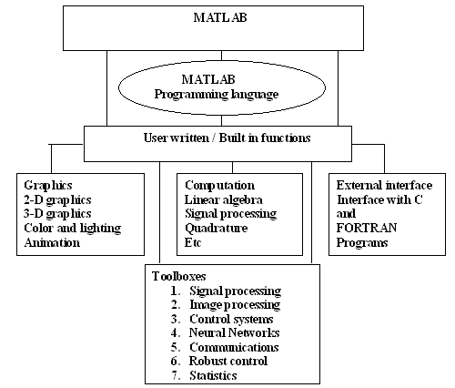

**Fig. 1 Applications of MATLAB**

**5.2**. **The MATLAB System:**

The MATLAB substance incorporates five fundamental parts:

**5.2.1 Development Environment**

This is the way of contraptions and workplaces that assistance you work MATLAB cutoff centers and realities. A fundamental scope of those devices is graphical UIs. It solidifies the MATLAB artistic creations region and Command Window, a value history, a bit of composing supervisor and debugger, and tries for diagram help, the workspace, records, and the pastime way.

**5.2.2 The MATLAB Mathematical Function Library:**

This is an enormous party of computational counts running from clear limits, like entire, sine, cosine, and complex number juggling, to more present day limits like component rotate, component Eigen regards, Bessel cutoff focuses, And practical Fourier changes.

**5.2.3 The MATLAB Language**

This is a shocking kingdom system/group dialect amidst oversee course illuminations, limits, records structures, enter/yield, and investigate composed programming features. It licenses both "programming inside the little" to hurriedly make brisk and tarnished unimportant games, and "programming inside the liberal" to make sizeable and confused utility projects.

**5.2.4 Graphics**

MATLAB has broad sketches situations for showing vectors and factors as diagrams, and aside from clarifying and printing these charts. It wires standard nation confines amidst regards to two-dimensional and three-dimensional information delineation, video orchestrating, improvement, and creation depictions. It likewise joins low-degree compels that empower you to exceptionally well change the vicinity of systems and paying little mind to make end graphical UIs to your MATLAB bundles.

**5.2.5 The MATLAB Application Program Interface (API)**

This is a lib. That enables you to frame C and Fortran prog's that interface amidst MATLAB. It solidifies work environments for calling designs from MATLAB (dynamic partner), calling MATLAB as a computational motor, and for breaking down and making MAT-documents.

**5. 3 Starting MATLAB**

On Windows stages, begin MATLAB by twofold tapping the MATLAB exchange way picture on your Windows work zone. On UNIX stages, begin MATLAB by impacting mat lab at the working portion to actuate. You can change MATLAB startup. For instance, you can change the registry in which MATLAB begins or thusly execute MATLAB affirmations in a substance record named new affiliations.

**5.3.1 MATLAB Desktop**

When you start MATLAB, the MATLAB work area shows up, containing contraptions (graphical UIs) for administering documents, segments, and applications related in the midst of MATLAB. The running with plot demonstrates the default work zone. You can change the arrangement of contraptions and reports to suit your necessities. For more information about the work district mechanical social events.

**5.3.2 .MATLAB Working Environment MATLAB Desktop:**

MATLAB Desktop is the vital Mat lab utility window. The work zone comprises of 5 sub home windows: the call for window, the workspace application, the present registry window, the summon records window, and no short of what one parent home windows, that are demonstrated definitely when the benefactor surely understood demonstrates a the distance sensible.

The charge window is the situated inside the purchaser writes MATLAB sales and verbalizations on the induce (>>) and in which the yield of these requesting is appeared. MATLAB delineates the workspace on the grounds that the procedure of fragments that the client makes in a piece session. The workspace program exhibits these segments and a few records about them. Twofold tapping on a variable inside the workspace programming dispatches the Array Editor, which likely used to get measurements and pay events exchange certain properties of the variable.

The blessing Directory tab over the workspace tab shows the substance of the current registry, whose way is respected in the blessing report window. For example, inside the windows working substance the way can likewise accord to the running with: C:MATLABWork, demonstrating that registry "work" is a subdirectory of the essential record "MATLAB", WHICH IS INSTALLED IN DRIVE C. Tapping at the dash inside the present stock window demonstrates a snappy assessment of starting late connected strategies. Tapping at the seize to the contrary aspect of the window connects with the customer to substitute the common once-over.

The Command History Window incorporates a report of the summons a customer has entered inside the charge window, alongside each present and past MATLAB periods. In support entered MATLAB charges possibly picked and re-executed from the summon History window by means of legitimate tapping on a demand or course of action of solicitations. This development dispatches a menu from which to pick diverse choices despite executing the expenses. This is an utilization to pick stand-out choices notwithstanding executing the expenses. This is helpful viewpoint while attempting exceptional issues in the midst of various costs in a work session.

**5.3.3 Using the MATLAB Editor to make M-Files**

The MATLAB manager is each an expression processor novel for making M-data and a graphical MATLAB debugger. The book pioneer can appear in a window and not utilizing an other character or it likely a sub window in the work zone. M-records are shown by means of the exchange .M, as in pixelup.M. The MATLAB stream chief window has exact draw down menus for assignments, as a case, sparing, seeing, and taking a gander at audits. Since it plays out some unmistakable exams additionally utilizes shading to isolate among different bits of code, this expression processor is clutched in light of the fact that the apparatus of want for trim and propelling M-limits. To open the movement real, type exchange on the prompt opens the M-report filename's in a digital book executive window, made creating. As observed some time starting past due, the record must be inside the stream registry, or in an abstract inside the side interest way.

**5.3.4 Getting Help**

The principal procedure to bargain in the midst of get help on line is to utilize the MATLAB help program, opened as a substitute window both by method for tapping at the question mark picture (?) at the artworks domain toolbar, or with the guide of impacting help to application at the impact in the demand window. The help Browser is a web programming made into the MATLAB work an area that introductions a Hypertext Markup Language (HTML) records. The Help Browser joins two sheets, the help set up sheet, used to find data, and the show sheet, used to see the realities.

Plain as day tabs other pilot sheet are utilized to play out an intrigue. For instance, help on a chose purpose of containment is gotten by choosing the interest tab, choosing Function Name in light of the fact that the Search Type, and after that composition inside the cutoff name inside the Search for teach. It is superb exercise to open the Help Browser nearer to the start of a MATLAB session to have help fast convenient in the midst of code advancement or distinctive MATLAB task.

Another method to good buy inside the midst of get for a specific factor of confinement is by creating document taken after with the aid of the maximum call at the demand incites. For example, growing document design exhibits documentation for the cutoff points referred to as set up inside the display sheet of the Help Browser. This summons opens the program on the off threat that it is not at once open.

**5.3.5 Saving and Retrieving a Work Session**

There are a few ways to deal with deal amidst extra and stack an entire work session or picked workspace factors in MATLAB. The scarcest complex is according to the running with. To spare the whole workspace, in a general sense right-tap on any sensible space in the workspace Browser window and select Save Workspace As from the menu that shows up. This opens a registry window that licenses naming the record and picking any facilitator in the structure in which to spare it. By then basically snap Save.

To spare a picked variable from the workspace, select the variable in the midst of a left snap and a compact navigate later right-tap on the included zone. By then select Save Selection As from the menu that shows up. This again opens a window from which a facilitator maybe spared the variable.

To pick different segments, utilize move snap or control click in the standard way, and after that utilization the framework basically depicted for a solitary variable. All records are spared in the twofold exactness, parallel outline amidst the amplification '. Tangle'. These spared reports normally are recommended as MAT-records. For instance, a session named, says mywork_2003-02-10, and would show up as the MAT-record mywork_2003_02_10.mat when spared. Additionally, a spared video called last video will show up when spared as final_video.mat.

**5.3.6 Graph Components**

MATLAB shows diagrams in an exceptional window known as a figure. To make a graph, you need to portray an arrange structure. In this manner each chart is put inside tomahawks, which are contained by the figure. The true blue visual depiction of the data is skilled in the midst of plans objects like lines and surfaces. These articles are drawn inside the arrangement with substance delineated by the tomahawks, which MATLAB conventionally makes especially to oblige the level of the data. The real data is secured as properties of the plans objects.

5.3.7 Plotting Tools

Plotting devices are related with figures and make a zone for making Graphs. These instruments draw in you to do the running with:

• Select from a wide assortment of diagram sorts

• Change the kind of graph that tends to a variable

• See and set the properties of portrayals objects

• Annotate plots amidst substance, shocks, and so on.

• Create and manage subplots in the figure

• Drag and drop data into plot

Exhibit the plotting instruments from the View menu or by tapping the plotting mechanical get together's picture in the figure toolbar, as appeared in the running with picture.

5.3.8 Editor/Debugger

Use the Editor/Debugger to make and research M-records, which are programs you write to run MATLAB limits. The Editor/Debugger gives a graphical UI to word preparing, and for M-record taking a gander at. To make or adjust a M-report use File > New or File > Open, or use the change work.

**5.3.9 Feature Development**

Feature headway happens as takes after:

• A MySQL feature is demonstrated in a Work log area.

• The Work log entry encounters detail, layout, designing and QA reviews (yet not by any stretch of the imagination in a strict progression).

• The MySQL feature is executed in a component tree.

• Feature trees are produced using and kept in a condition of congruity in the midst of the MySQL basic change tree, which is called TRUNK

• When a part has been executed, it encounters a code study.

• When the code overview is done, the part tree is offered over to QA (quality certification).

• QA tests the part, the implementer fixes bugs, and QA over the long haul "shuts down" the component.

• Once the segment is shut down, it is joined into TRUNK. Thusly, TRUNK will total features and bug settles after some time. Wide backslide testing is performed on TRUNK continually, keeping TRUNK close Release Candidate (RC) quality reliably.

**5.4 Feature Testing**

New capabilities in MySQL are made and attempted in discrete phase timber earlier than they're pushed to TRUNK. Quality goals for brand new functions are the going with:

• Complete helpful and nonfunctional take a look at extent of changed and new price

• No backslides

• At least extra than eighty% code scope QA association starts offevolved while the necessities and particulars of the section are settled with the aid of the headway collecting.

QA overviews available files and gives contribution on the association, accommodation, testability, et cetera. An alternate takes after in the midst of the designer and modifications are fabricated from course to make sure that the element probably attempted.

Once the particulars and necessities are suitable, QA affects the test to organize which reviews all circumstances which are to be attempted. This fuses free tests, becoming a member of exams, nonfunctional tests, et cetera. The take a look at configuration is kept an eye on with the aid of designers and partner QA buddies. While the planners are forming the component code, QA engineers start tackling the mechanized tests, test status quo enhancements, et cetera. The final spherical of trying out starts after the aspect has passed code studies. This degree can last anyplace among numerous days to months, structured upon the multifaceted concept of the factor, satisfactory of the code, variety of bugs found, et cetera. Features get close down when the going with situations are met:

• No known bugs in the new part – This is inside and out affirmed and even minor bugs are not permitted. We accept that bugs are most simple to settle when the code is new, and thusly this can enable us to pass on highlights that are of high bore.

• No known falls away from the faith – A part gets made on a tree which gets endeavored as regularly as conceivable through a consistent joining testing contraption. Any descends into sin are seen and settled before signoff.

• Adequate code scope numbers – A code scope report is made for the changed lines of code and the base expected degree is 80%. Most highlights have a degree of over 90%. Any revealed lines of code are broke down and, wherever conceivable, new tests are added to develop code scope.

• Every single new test are added to the mechanized apostatize suite.

The MySQL web page depicts MySQL as the "world's maximum widespread Open Source database." Its regularity isn't any weakness maintained via the manner that on the off chance that you require MySQL for non-enterprise make use of, you could download a reproduction loose from the internet site web page. MySQL is about dependably packaged amidst the PHP internet scripting vernacular, and the 2 matters are as regularly as attainable regarded stated collectively. Most Linux spreads run with MySQL and PHP as popular and MySQL has been ported for use to a large collection of stages. Because of its packaging amidst PHP, MySQL is routinely utilized as a database lower back quit to a web server.

DBMS MySQL is what's referred to as a Database Management element (DBMS). The company substance picks how the statistics is secured, masterminded and recuperated, and also controlling client get entry to to it. Each time a purchaser recoups records, eradicates facts, or contains more records, the DBMS deals with the request. The patron can't get to the records facts mainly, he can sincerely speak within the midst of the DBMS.

The company substance is an impediment that controls get entry to to the shrouded records., and cannot go especially to the database itself. MySQL Databases MySQL can manipulate multiple databases without delay. For instance, while you gift MySQL, the detail makes the element database which is called mysql. This database includes most of the 2 Database Design Manual: using MySQL for Windows facts required to describe any of the sports that MySQL desires to carry out. It shops purposes of enthusiasm of diverse databases, clients and every and every different file that the element makes use of to shop facts. It itself is an aggregation of records used for a specific reason.

This makes My SQL self-delineating, in that the tables that it shops are used to depict particular tables that it stores whilst you are affecting your personal specific plans of facts to make those in some other database. In this e-book we are able to use the mysql database to examine particular shape limits, however by a ways maximum of the alternative information that we make might be secured in a database called mysqlfast. MySQL can without a number of a widen manipulate multiple database, so as to hold your tables being combined up for thing facts, it's far first-rate to drag back them by using the use of particular databases.

**5.5 SQ Lite**

This SQ Lite instructional exercise demonstrates to all of you that you need to know to start using SQ Lite sufficiently. You will learn SQ Lite through wide hands-on sharpens. SQ Lite Tutorial If you have been working in the midst of other social database organization elements e.g., My SQL, Posture SQL, Oracle, Microsoft SQL Server, et cetera., and you got some answers concerning SQ Lite. In addition, you are intrigued to get some answers concerning it. In case your sidekicks recommended you use SQ Lite database as opposed to essential archives to regulate composed data in your applications. You have to start in the midst of SQ Lite rapidly to check whether you can utilize it for your applications. In case you are basically starting learning SQL and need to use SQ Lite as the database system. In case you are one of the overall public portrayed over, this SQ Lite instructional exercise is for YOU. SQ Lite is an open source, zero-game plan, autonomous, stay single, trade social database engine expected to be embedded into an application.

**Getting Help:**

The major way to get help online is to use the MATLAB assist browser, opened as a separate window each thru clicking at the query mark symbol (?) at the computing device toolbar, or via typing help browser at the activate inside the command window. The assist Browser is an internet browser protected into the MATLAB computer that displays a Hypertext Markup Language (HTML) files. The Help Browser includes two panes, the help navigator pane, used to discover statistics, and the display panel used to view the facts. Self-explanatory tabs apart from navigator pane are used to carry out an are looking for.

**Appendix B**

# INTRODUCTION TO DIGITAL IMAGE PROCESSING

# 6.1 What is DIP?

A photo can be described as a -dimensional characteristic f(x, y), in which x & y are spatial coordinates, & the amplitude of f at any pair of coordinates (x, y) is known as the depth or grey stage of the photograph at that point. When x, y & the amplitude values of f are all finite discrete portions, we name the image a virtual image. The discipline of DIP refers to processing digital photo through a virtual laptop. Digital photograph consists of a finite range of factors, every of which has a selected location & charge. The elements are known as pixels.

Vision is the most advanced of our sensor, so it isn't unexpected that photoplay the single maximum essential function in human belief. However, an assessment to people, who're confined to the visible band of the EM spectrum imaging machines cowl nearly the whole EM spectrum, beginning from gamma to radio waves. They can characteristic additionally on pix generated by way of resources that humans aren't familiar with associating with the picture.

There is not any giant agreement amongst authors regarding in which picture processing stops & different related areas which include photo evaluation& pc imaginative and prescient start. Sometimes a difference is made with the resource of defining picture processing as a subject in which every the input & output at a process are photos. This is limiting & relatively artificial boundary. The vicinity of photograph evaluation (picture know-how) is in between photo processing & computer imaginative and prescient.

There aren't any uncomplicated obstacles within the continuum from picture processing at one end to complete imaginative and prescient at the alternative. However, one useful paradigm is to undergo in thoughts three sorts of automatic strategies on this continuum: low-, mid-, & excessive-degree approaches. The low-degree approach involves primitive operations which incorporate image processing to reduce noise, evaluation enhancement & picture sharpening. A low- diploma technique is characterized by the resource of the reality that both its inputs & outputs are photographs. Mid-degree procedure on snapshots includes duties together with segmentation, description of that object to lessen them to a shape suitable for pc processing & type of character gadgets. A mid-diploma method is characterized thru the fact that its inputs commonly are photographs however its outputs are attributes extracted from the one's photos. Finally higher- stage processing includes “Making enjoy” of an ensemble of recognized devices, as in image evaluation & at the along manner stop of the continuum acting the cognitive competencies typically related to human imaginative and prescient.

Digital picture processing, as already described is used efficiently in a large range of areas of wonderful social & monetary rate.

**6.2 What is a photo?**

An image is represented as a two dimensional characteristic f(x, y) where x and y are spatial co-ordinates and the amplitude of ‘f’ at any pair of coordinates (x, y) is called the depth of the picture at that point.

**Grayscale photograph:**

A grayscale photograph is a feature I (xylem) of the two spatial coordinates of the picture plane.

I(x, y) is the depth of the photo at the factor (x, y) at the photographing plane.

I (xylem) takes non-poor values expect the picture is bounded thru a rectangle [0, a] [0, b]I: [0, a]  [0, b]  [0, facts)

**Color photo:**

It may be represented through 3 capabilities, R (xylem) for crimson, G (xylem) for green and B (xylem) for blue.

A picture can be continuous with respect to the x and y coordinates and also in amplitude. Converting such an photo to digital shape calls for that the coordinates in addition to the amplitude to be digitized. Digitizing the coordinate’s values is referred to as sampling. Digitizing the amplitude values is known as quantization.

**6.3 Coordinate conventions:**

The end result of sampling and quantization is a matrix of actual numbers. We use primary procedures to symbolize virtual snap shots. Assume that an photograph f(x, y) is sampled in order that the resulting image has M rows and N columns. We say that the image is of period M X N. The values of the coordinates (xylem) are discrete portions. For notational readability and convenience, we use integer values for those discrete coordinates. In many picture processing books, the image beginning is defined to be at (xylem)=(0,0).

The subsequent coordinate values along the number one row of the photograph are (xylem)=(zero,1).It is essential to keep in mind that the notation (0,1) is used to suggest the second sample along the primary row. It does not suggest that these are the real values of physical coordinates at the same time as the photograph become sampled. Following figure shows the coordinate convention. Note that x stages from zero to M-1 cease y from 0 to N-1 in integer increments.

The coordinate convention used within the toolbox to signify arrays is not just like the previous paragraph in minor tactics. First, in region of the usage of (xylem) the toolbox uses the notation (race) to indicate rows and columns. Note, however, that the order of coordinates is much like the order discussed inside the preceding paragraph, in the sense that the first detail of a coordinate topples, (alb), refers to a row and the second to a column.

The specific difference is that the beginning of the coordinate gadget is at (r, c) = (1, 1); for that reason, r degrees from 1 to M and c from 1 to N in integer increments. IPT documentation refers to the coordinates. Less often the toolbox additionally employs some other coordinate convention known as spatial coordinates which uses x to refer to columns and y to refers to rows. This is the opportunity of our use of variables x and y.

**6.4 Image as Matrices:**

The previous dialogue leads to the subsequent illustration for a digitized photograph feature:

f (0, 0) f (0, 1) ……….. f (0, N-1)

f (1, 0) f (1, 1) ………… f (1, N-1)

f (xylem) = . . . . . . f (M-1, 0) f (M-1, 1) ………… f (M-1, N-1) The right side of this equation is a digital photograph with the aid of definition. Each element of this array is known as an image detail, photo element, pixel or pel. The terms photo and pixel are used throughout the rest of our discussions to indicate a digital photo and its elements. A virtual photo can be represented evidently as a MATLAB matrix:

f (1, 1) f (1, 2) ……. f (1, N) f (2, 1) f (2, 2) …….. f (2, N) . . . f = . . . f (M, 1) f (M, 2) …….f (M, N) Where f (1, 1) = f (zero, 0) (be conscious the use of a monoscope font to indicate MATLAB portions). Clearly the 2 representations are identical, except for the shift in beginning vicinity. The notation f (p, q) denotes the detail positioned in row p and the column q. For example f (6, 2) is the element in the sixth row and second column of the matrix f. Typically we use the letters M and N respectively to suggest the range of rows and columns in a matrix. A 1xN matrix is called a row vector at the same time as an Mx1 matrix is known as a column vector. A 1x1 matrix is a scalar.

Matrices in MATLAB are stored in variables with names which encompass A, a RGB, real array and so on. Variables ought to start with a letter and include best letters, numerals, and underscores. As stated within the preceding paragraph, all MATLAB quantities are written using monoscope characters. We use conventional Roman, italic notation such as f(x, y), for mathematical expressions.

**6.5. Reading Images:**

Images are examine into the MATLAB surroundings the use of characteristic imread whose syntax is

Imread (‘filename’)

**Format name Description recognized extension** TIFF Tagged Image File Format .tif, .tiff JPEG Joint Photograph Experts Group .jpg, .jpeg GIF Graphics Interchange Format .gif BMP Windows Bitmap .bmp PNG Portable Network Graphics .png XWD X Window Dump .xwd

Here filename is a spring containing the whole of the photograph file(including any relevant extension).For example the command line

>> f = imread (‘eight. Jpg’);

Reads the JPEG (above table) photograph chestxray into photo array f.

Note the usage of unmarried charges (‘) to delimit the string filename.

The semicolon on the cease of a command line is utilized by MATLAB for suppressing output. If a semicolon isn't always included. MATLAB presentations the consequences of the operation(s) laid out in that line. The prompt image (>>) designates the start of a command line, as it appears in the MATLAB command window.

When as within the previous command line no course is blanketed in filename, imread reads the record from the modern listing and if that fails it attempts to discover the report in the MATLAB search path. The most effective way to study an picture from a certain directory is to include a complete or relative path to that listing in filename.

For example,

>> f = imread (‘D: myimageschestxray.Jpg’);

reads the image from a folder known as my pictures at the D: force, while

>> f = imread(‘ . Myimageschestxray .Jpg’);

Reads the picture from the my photos subdirectory of the present day of the cutting-edge running listing.

The modern listing window at the MATLAB laptop toolbar shows MATLAB’s contemporary running directory and provides an easy, manual manner to change it. Above table lists a number of the maximum of the famous image/photographs formats supported via imread and imwrite. Function size offers the row and column dimensions of an image:

>> Length (f) ans = 1024 * 1024

This feature is mainly beneficial in programming while used in the following form to determine automatically the dimensions of an picture:

>>[M,N]=size(f); This syntax returns the quantity of rows(M) and columns(N) within the photograph.

The complete feature presentations extra records approximately an array.

For instance ,the statement>> whos fgives Name size Bytes Class F 1024*1024 1048576 unit8 arrayGrand total is 1048576 elements using 1048576 bytes The unit8 entry shown refers to one of several MATLAB data classes. A semicolon at the end of a whose line has no effect ,so normally one is not used.**6.6 Displaying Images:** Images are displayed on the MATLAB desktop using function imshow, which has the basic syntax: imshow(f,g) Where f is an image array, and g is the number of intensity levels used to display it. If g is omitted ,it defaults to 256 levels .using the syntax Imshow (f, {low high}) Displays as black all values less than or equal to low and as white all values greater than or equal to high. The values in between are displayed as intermediate intensity values using the default number of levels .Finally the syntax Imshow(f,[ ]) Sets variable low to the minimum cost of array f and excessive to its maximum fee. This shape of imshow is useful for showing snap shots which have a low dynamic range or that have splendid and terrible values.

Function pixval is used regularly to show the depth values of individual pixels interactively. This function suggests a cursor overlaid on an image. As the cursor is moved over the photograph with the mouse the coordinates of the cursor role and the corresponding intensity values are validated on a show that looks under the discern window .When working with color pix, the coordinates in addition to the red, green and blue components are displayed. If the left button on the mouse is clicked after which held pressed, pixval shows the Euclidean distance a number of the preliminary and contemporary cursor locations.

The syntax form of hobby here is Pixval which shows the cursor at the final photograph displayed. Clicking the X button at the cursor window turns it off.

The following statements look at from disk an photograph called rose_512.Tif extract easy statistics approximately the picture and display it the usage of imshow

:>>f=imread(‘rose_512.tif’);>>whos f

**Name Size Bytes Class** F 512*512 262144 unit8 arrayGrand total is 262144 elements using 262144 bytes>>imshow(f) A semicolon on the quit of an imshow line has no impact, so commonly one is not used. If some other photograph,g, is displayed using imshow, MATLAB replaces the photo within the screen with the new photo. To preserve the primary photograph and output a 2nd image, we use feature figure as follows:

>>discern ,imshow(g)

Using the declaration >>imshow(f),parent ,imshow(g) presentations each pictures.

Note that a couple of command may be written on a line,so long as unique instructions are nicely delimited by commas or semicolons. As cited in advance, a semicolon is used each time it's far preferred to suppress screen outputs from a command line.

Suppose that we have just read an photo h and locate that the usage of imshow produces the photo. It is apparent that this photograph has a low dynamic variety, which can be remedied for show purposes via the usage of the declaration. >>imshow(h,[ ])